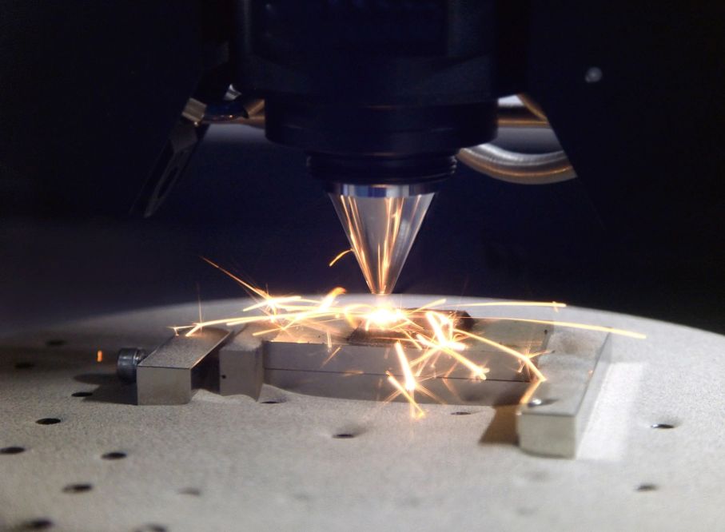

**ITP Interim Report on additive Manufacturing by Group 3**

**Table of Contents**

**1.** **INTRODUCTION** 4

**2.** **SYSTEM ENGINEERING AND REQUIREMENTS** 4

**2.1 BACKGROUND OF THE PROJECT** 4

**2.2 AIMS** 4

**2.3** **OBJECTIVES** 4

**2.4** **TECHNICAL REQUIREMENTS ANALYSIS** 5

**3.** **LITERATURE REVIEW** 7

**4.** **PROJECT MANAGEMENT AND PLANNING** 10

**4.1 TEAM ORGANIZATION** 11

**4.2 WORK BREAKDOWN STRUCTURE** 11

**4.4** **RISK REGISTER** 19

**5.** **PROPOSED SYSTEM DESIGN** 21

**5.1 SYSTEM IDENTIFICATION** 21

**5.2 LINEAR REGRESSION** 22

**5.3 POLYNOMIAL REGRESSION** 25

**5.4 SUPPORT-VECTOR REGRESSION** 28

**5.5 RANDOM FOREST** 29

**5.6 NEURAL NETWORK** 32

**6.** **PRILIMINARY TECHNICAL PLAN** 33

**7.** **CONCLUSION** 34

**8.** **REFERENCES** 34

**List of Tables**

Table 1: Pugh Matrix for different Surrogate Modelling Methods 6

Table 2: List view of the Work breakdown structure 12

Table 3: Risk register to show the possible risks associated with this project and their mitigation plans 20

Table 4: Risk Matrix to show the severity and the likelihood associated with the risks 20

**List of Figures**

Figure 1:Team Organization Structure 11

Figure 2: Work breakdown structure 14

Figure 3: Gantt chart to show the background, aims and objectives section 15

Figure 4: Gantt chart to show the Technical requirements definition and WBS section 15

Figure 5: Gantt chart to show the Gantt chart and the risk register section 16

Figure 6: Gantt chart to show the Meetings and Interim Report section 16

Figure 7: Gantt chart to show the Literature Review and Proposed Systems Design section 16

Figure 8: Gantt chart to show the Proposed Systems Design section 17

Figure 9: Gantt chart to show Interim Report Writing and slack due to Easter break section 17

Figure 10:Gantt chart to show the Project execution, regression and validation section 17

Figure 11:Gantt chart to show the Technical Work Evidence and Final Solution section 18

Figure 12:Gantt chart to show the Final Solution section 18

Figure 13: Gantt chart to show the Introduction and Background section 18

Figure 14:Gantt chart to show the Technical Approach and Results Analysis and Conclusions section 19

Figure 15: Gantt chart to show the Final Report Writing section 19

# **INTRODUCTION**

The objective of this report is to analyse the multi-component diffusion related issues faced by Thermo Calc Software in recent years during 3D printing metal objects from the alloy of Calcium, Zinc and Magnesium and to propose the most accurate and computationally fast machine learning method to infer thermodynamic and mobility data.

# **SYSTEM ENGINEERING AND REQUIREMENTS**

## **BACKGROUND OF THE PROJECT**

Additive manufacturing is a method for creating components directly from 3D model data, typically building them layer by layer, as opposed to traditional subtractive methods like machining or milling. The market offers a wide variety of Additive Manufacturing equipment, and their availability is steadily increasing. This equipment can generally be categorized into powder bed, powder fed, and wire fed systems.

In the process of creating metallic Additive Manufacturing parts or alloys, there is a complicated thermal cycle that includes directional heat removal and repeated cycles of melting and quick solidification. Additionally, many alloys undergo repeated transformations in their solid state. These elements add a level of complexity to understanding how microstructures develop and their properties, which is not usually seen in conventional manufacturing processes.

Qualification and certification have consistently been recognized as obstacles to the broad acceptance of AM for structurally critical parts; the existing procedure is overly expensive and time-consuming. Therefore, the importance of surrogate model to efficiently model multicomponent diffusion to efficiently determine the process of additive manufacturing process.

## **AIMS**

The aim of the project is to generate the most accurate and computationally fast machine learning method to infer thermodynamic and mobility data for fast diffusion of the metallic alloys during the 3D printing process.

## **OBJECTIVES**

The objective of this project is as follows:

1. To investigate that whether machine learning can accelerate simulations of multi-component diffusion.
2. To create and validate a mathematical and computational ML framework for modeling complex material behaviors in metal AM.
3. To determine what is the most accurate and computationally fast machine learning method to infer thermodynamic and mobility data.

## **TECHNICAL REQUIREMENTS ANALYSIS**

Thermodynamic and mobility data for modelling multi-component diffusion in MG-Ca-Zn alloys for 3D printing is given for analyzing the fast diffusion criteria’s using machine learning algorithms. There are several machine learning algorithms like Neural Network (NN), Linear Regression (LR), Polynomial Regression (PR), Random Forest Regression, Support Vector Regression, Systems Identification, Kriging, Radial Basis Functions (RBF), and Response Surface Model (RSM) have the potential of predicting the multi-component diffusion in more efficient way and hence can accelerate the simulation of multi-component diffusion in metal additive manufacturing. The top level requirement is like achieving accuracy & efficiency in simulating the multi-component diffusion in the metal additive manufacturing **[1]**.

Functional requirements are the description of the specific behaviors and functionalities that the designed system shall perform, while non-functional requirements specify the quality concepts and constraints that govern the system's operation. The functional and non-functional requirements of the surrogate modelling for metal additive manufacturing can be identified as follows.

**Functional requirements:**

The designed surrogate model shall be able to collect and preprocess data. It should be trained properly. The surrogate model shall involve verification and validation and it will be optimized.

**Non-functional requirements:**

The designed surrogate model shall obtain a prediction accuracy of no less than 95%. The processing time of the surrogate model shall be reasonable while the data resource utilization shall be minimized (less than half of the original dataset size). The model should have a good

Table 1: Pugh Matrix for different Surrogate Modelling Methods

|  |  |  |  |  |  |  |  |  |  |  |
| --- | --- | --- | --- | --- | --- | --- | --- | --- | --- | --- |
| No. | Requirement Description | Weight | NN (Baseline) | LR | PR | RFR | SVR | SI | Kriging | RBF |
| 1 | Accuracy | 5 | 0 | -9 | -3 | -1 | -3 | 9 | -3 | -3 |
| 2 | Computational Efficiency | 4 | 0 | 9 | 9 | 1 | 3 | -9 | -9 | -9 |
| 3 | Feasibility | 3 | 0 | 9 | 9 | 1 | 1 | 0 | -3 | 1 |
|  | Weighted Total |  | 0 | 18 | 48 | 2 | 0 | 9 | -60 | -28 |

generalization to new datasets and it should be robust to varying input conditions and shall be able to handle the noise in the input dataset. It should operate reliably under designed conditions and the availability for target users shall be ensured. The surrogate model shall remain safe operations and shall not cause any damage to the users and it shall protect sensitive data used for training, validating, and predicting.

The non-functional requirements are mainly used for evaluating the designed surrogate model. Hence, a Pugh matrix can be generated to support the selection of the final surrogate model as well as the ensemble of surrogates.

The Pugh Matrix in table 1 for different surrogate modelling methods (NN for Neural Network, LR for Linear Regression, RFR for Random Forest Regression, SVR for Support Vector Regression, SI for Systems Identification, RBF for Radial Basis Function) shows the accuracy, computational efficiency and the feasibility of the models.

Based on the assumption that a neural network should have a good performance in predicting the multi-component diffusion features, the neural network is selected as the baseline model for the concept evaluation and selection process. As shown in Table 1, the models are assigned with different scores based on the comparative performances in the requirements of accuracy, computational efficiency, and feasibility **[1]**. The scores reflect the difference between the current model and the baseline model. The larger the score is, the greater the difference will be.

# **LITERATURE REVIEW**

Additive Manufacturing (AM) equipment can be categorized into three main systems: powder bed, laser powder injection, and free form fabrication (FFF). Each system has unique characteristics. The powder bed system is known for its smaller build volume of less than 0.03 m³ and its ability to produce high-resolution items. In contrast, the powder feed system, with a build volume greater than 1.2 m³, is better suited for scaling up build volumes and is advantageous for refurbishing worn or damaged components due to its larger build volume. The wire feed system excels in large build volumes and requires extensive machining, where a single bead of material is deposited and built upon in subsequent passes to develop 3D structures **[2]**.

Materials processed using AM undergo Thermal Processing Cycles, necessitating a deep understanding of the relationship between microstructure, processing, and properties specific to AM. Standardizing file formats for additive manufacturing is crucial for seamless transfer of designs between different hardware and software. One of the key technological challenges in AM includes process controls, sensors, and models, especially in process control and modelling. There's a need for closed-loop process control to ensure quality, as this is intricately related to the material's past processing history, including measuring the melt pool size. AM is particularly favored for small production lots where the higher cost of AM-specific raw materials is balanced by lower fixed costs compared to conventional manufacturing. This balance is attributed to the speed, versatility, and adaptability of AM processes. AM is a process of making parts from 3D model data. During fabrication, metallic AM parts/alloys experience a complex thermal history involving directional heat extraction, and repeated melting and rapid solidiﬁcation. Many alloys also experience repeated solid state phase transformations. These factors introduce complexities to the analysis of microstructural evolution and properties not typically found in conventional processes. To tackle this problem, technological alternative means of accelerated qualiﬁcation are needed depending heavily on the reduction of recurrent costs, i.e., the cost of the starting materials used in AM fabrication. Utilizing Machine Learning to obtain the specific model of the particular case will give more representation during the multicomponent diffusion process **[2]**.

Metal additive manufacturing (AM) has emerged as a transformative technology, revolutionizing the production of complex metal parts with unprecedented design freedom and efficiency. However, the inherent variability and complexity in the AM process pose significant challenges in ensuring consistent material properties and performance. To address these challenges, researchers have turned to machine learning (ML) techniques to enhance understanding, optimize process parameters, and predict material properties. In their paper titled "Machine Learning for Materials Development in Metals Additive Manufacturing," N.S. Johnson et al. provide a comprehensive review of the application of ML in advancing materials development within the realm of metal AM **[3]**.

From this paper the significance of ML in accelerating materials development and process optimization in metal AM is understood. It emphasizes the need for robust ML models capable of handling large and heterogeneous datasets to uncover intricate correlations between process parameters, microstructure, and mechanical properties. Johnson et al. delve into various ML algorithms and methodologies employed in the context of metal AM, ranging from classical regression techniques to advanced deep learning approaches **[3]**.

The authors discuss the pivotal role of input data in ML modeling, encompassing diverse parameters such as powder characteristics, printing parameters, thermal history, and post-processing conditions. By integrating physics-based models with data-driven approaches, researchers have achieved enhanced predictive capabilities, facilitating the optimization of AM processes for desired material properties. Johnson et al. elucidate the importance of feature engineering in extracting meaningful insights from complex datasets, enabling the identification of critical process-structure-property relationships. This insight will be helpful to identify the right machine learning programs for this project and to understand that how the input data set will be used for training the program **[3]**.

Furthermore, the paper highlights the significance of uncertainty quantification in ML models, particularly in the context of AM where process variability and material heterogeneity are prevalent. The importance of data preprocessing and sampling is evident from this discussion so that the program generate the right model **[3]**.

In the context of the assignment, which aims to investigate the role of rapid diffusion in mitigating brittleness in 3D-printed metal parts, the insights gleaned from Johnson et al.'s review are invaluable. By leveraging ML techniques, the company can analyze input data related to diffusion kinetics, microstructural evolution, and mechanical properties to elucidate the relationship between diffusion rate and brittleness reduction. Through the development of ML models trained on experimental data, the company can optimize process parameters to expedite diffusion while ensuring the desired mechanical properties of the final product. Additionally, the incorporation of uncertainty quantification techniques enables the identification of potential risks and the establishment of robust manufacturing protocols **[3]**.

Johnson et al.'s review serves as a comprehensive guide to the application of ML in materials development for metal AM. The insights provided underscore the transformative potential of ML in optimizing process parameters, predicting material properties, and accelerating innovation in metal AM. By embracing ML methodologies outlined in the paper, companies can unlock new opportunities for enhancing product quality, reducing production costs, and advancing the adoption of metal AM in various industries **[3]**.

The integration of surrogate models (SMs) with computational efficiency is a pivotal aspect of advancing engineering design methodologies. Traditional methods like Response Surface Methodology (RSM) and kriging excel in achieving accurate surrogate models, while Evolutionary Algorithms (EAs) are better suited for addressing high-dimensionality issues and yielding faster results. Additionally, the emergence of Multivariate Adaptive Regression Splines (MARS) showcases an evolution towards faster and more accurate surrogate modelling techniques. This trend underscores the growing integration of deep neural networks with EAs, presenting a comprehensive approach to surrogate modelling. Looking ahead, future research directions suggest exploring deep neural networks' potential and integrating them with other EA methods through Ensemble of Surrogates (EOS), thereby balancing various SMs' strengths and weaknesses **[4]**.

A notable contribution lies in the development of a framework facilitating surrogate model selection based on specific requirements, emphasizing the trade-off among size, accuracy, and computational time. Providing practical guidance and a mental model for researchers and industry practitioners, especially when faced with incomplete information about engineering design problems, is crucial. Moreover, while advancements in computing power have enabled more efficient high-fidelity simulations, the computational cost associated with sophisticated high-fidelity computer experiments remains a challenge, particularly for probabilistic design problems. Automating the surrogate model selection process through the development of a rule base holds promise in significantly enhancing the efficiency of design analysis processes. Furthermore, collaborative efforts between academia and industry, supported by funding from organizations like Tata Consultancy Services and The University of Oklahoma, underscore the importance of collaborative research endeavors in advancing engineering design methodologies **[4]**.

Jakub Kudela et al. **[1]** showed that surrogate modeling is a powerful tool for addressing black-box problems and offers significant savings in computational resources and time. However, selecting the appropriate surrogate model remains a crucial challenge. In their research, the authors have examined prominent publications that utilize surrogate modeling for computations based on the finite element method. They provide insights into how surrogate modeling operates, encompassing aspects such as data sampling and various types of surrogates including Linear Regression, Kriging, Support Vector Regression, Artificial Neural Networks, among others. Additionally, the authors delve into the validation process for each surrogate model, exploring concepts such as ensembles of surrogates and multi-fidelity models. Their study covers diverse applications including predictions, sensitivity analysis, uncertainty quantification, and surrogate-based optimization, showcasing recent advancements and practical implementations. Furthermore, the authors present a comprehensive overview of widely-used and recently developed software tools suitable for such applications.

The research conducted in this study aims to educate readers on various surrogate modeling methods, their validation procedures, sensitivity analysis, and other essential factors involved in the surrogate modeling process. This information serves to guide the selection of an appropriate surrogate model and the correct procedures to follow throughout the modeling process especially when there is no background understanding of the data **[1]**.

When the background of the data provided is unknown, still it helps to provide informed decisions when selecting a surrogate model. It gives a better understanding of the strengths and weaknesses associated with each model, helping in the process of determination of the most suitable surrogate model required for any specific task **[1]**.

Atwya and Panoutsos **[5]** demonstrated the importance of prior-knowledge in improving the predictive performance of trained neural network. The proposed framework optimizes neural network structure using prior-knowledge, enhancing prediction accuracy and theory consistency. In the training stage, methods such as line search for optimizing hidden units and k-fold cross-validation for improving generalization eliminate dataset dependency and enhance model robustness. This proposed framework shows great impact in introducing a more guided and efficient modelling process of theory-informed data-driven models with parameter initialization, probabilistic models, theory-based regularization, and constrained optimization. Furthermore, benchmark testing and hyper-parameter sensitivity investigation demonstrate the superiority of physics-guided neural networks over traditional ones, particularly in handling small and noisy datasets, offering accurate and computationally efficient solutions aligned with physics-based simulations.

# **PROJECT MANAGEMENT AND PLANNING**

Project Management is another important method which helps to manage the project perfectly and efficiently. Total project work has been divided into smaller parts and have shown below as work breakdown structure. Agile methodology has been used to manage this project and the Gantt chart has been updated accordingly as the project progresses.

## **TEAM ORGANIZATION**

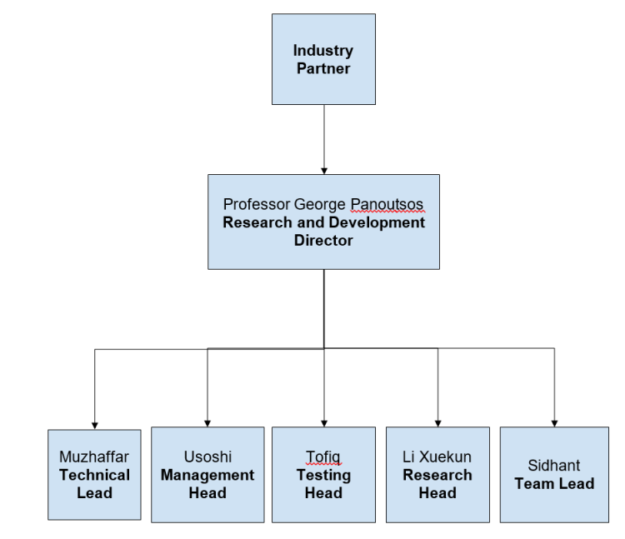

Figure 1:Team Organization Structure

## **WORK BREAKDOWN STRUCTURE**

The list view of the work breakdown structure is shown below:

Table 2: List view of the Work breakdown structure

|  |  |
| --- | --- |
| Task No. | Task Description |
| 1 | Systems Engineering and Requirements |
| 1.1 | Background, Aims and Objectives |
| 1.1.1 | Project Summary |
| 1.1.2 | Top Level Requirements |
| 1.1.3 | Concept of Operations |
| 1.1.4 | Concept Evaluation and Selection (Pugh Matrix) |
| 1.2 | Technical Requirements Definition |
| 1.2.1 | Functional Requirements |
| 1.2.2 | Non-functional Requirements |
| 1.2.3 | Verification & Validation Plan |
| 2 | Project Management |
| 2.1 | Work Breakdown Structure |
| 2.1.1 | Organization Structure |
| 2.1.2 | Deliverables Identification |
| 2.1.3 | Detailed Project Hierarchical Decomposition |
| 2.2 | Gantt Chart |
| 2.2.1 | Logical Tasks Structure |
| 2.2.2 | Task Start/End Date |
| 2.2.3 | Relationship between Tasks |
| 2.2.4 | Agile Project Management |
| 2.3 | Project Risk Register |
| 2.3.1 | Project Risks Identification |
| 2.3.2 | Assign Likelihood & Impact Score |
| 2.3.3 | State Mitigation Ownership |
| 3 | Interim Report |
| 3.1 | Literature Review |
| 3.1.1 | Literature Exploration |
| 3.1.2 | Critical Appraisal |
| 3.1.3 | Referencing |
| 3.2 | Proposed System Design |
| 3.2.1 | Explanation of Proposed Design Solution |
| 3.2.2 | Explanation & Critical Appraisal of Theoretical Work |
| 3.2.3 | Explanation & Critical Appraisal of Computational Work |
| 3.2.4 | Explanation & Critical Appraisal of Experimental Work |
| 3.2.5 | Understanding & High-Level Skills Demonstration |
| 3.2.6 | Conclusion |
| 3.3 | Report Writing |
| 4 | Software Development |
| 4.1 | Surrogate Modeling Execution |
| 4.1.1 | Data Collection |
| 4.1.2 | Design Construction |
| 5 | Poster Presentation |
| 5.1 | Technical Work Evidence |
| 5.1.1 | Justification of Methodology |
| 5.1.2 | Evidence of Design |
| 5.2 | Final Solution |
| 5.2.1 | Testing and Evaluation |
| 5.2.2 | Analysis of Results |
| 5.2.3 | Discussion of Model Performance |
| 5.2.4 | Compatibility of the solution with performance |
| 6 | Final Report |
| 6.1 | Introduction and Background |
| 6.1.1 | Motivation |
| 6.1.2 | Background Summary |
| 6.1.3 | Aims & Objectives |
| 6.1.4 | Literature Review |
| 6.1.5 | Referencing |
| 6.2 | Technical Approach |
| 6.2.1 | Justification |
| 6.2.2 | In-Depth Description |
| 6.2.3 | Connection to Case Study |
| 6.3 | Results, Analysis and Conclusions |
| 6.3.1 | Demonstration of Efficiency |
| 6.3.2 | Analysis of Results |
| 6.3.3 | Conclusion |
| 6.4 | Report Writing |

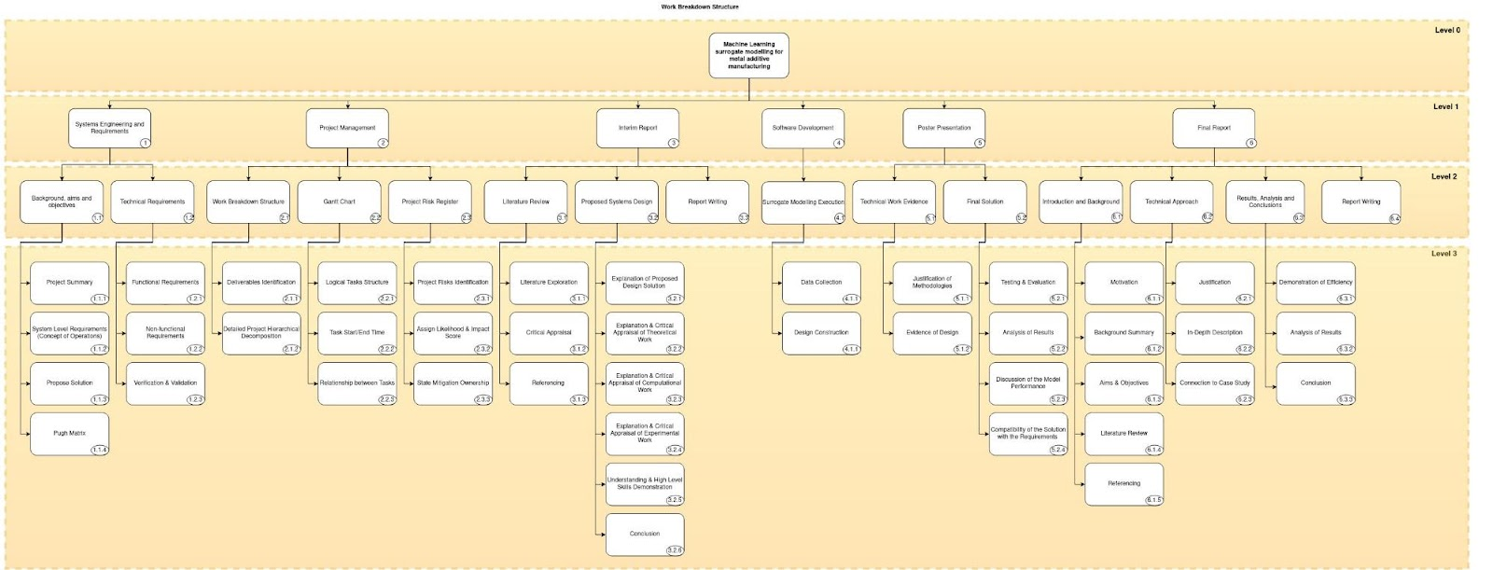

Figure 2: Work breakdown structure

**4.3 GANTT CHART**

Gantt Chart has been made to show the breakdown structure of the project and the allocation of the work among the team members. Since, the Gantt chart is a bigger one so it has been divided it into parts for better understanding.

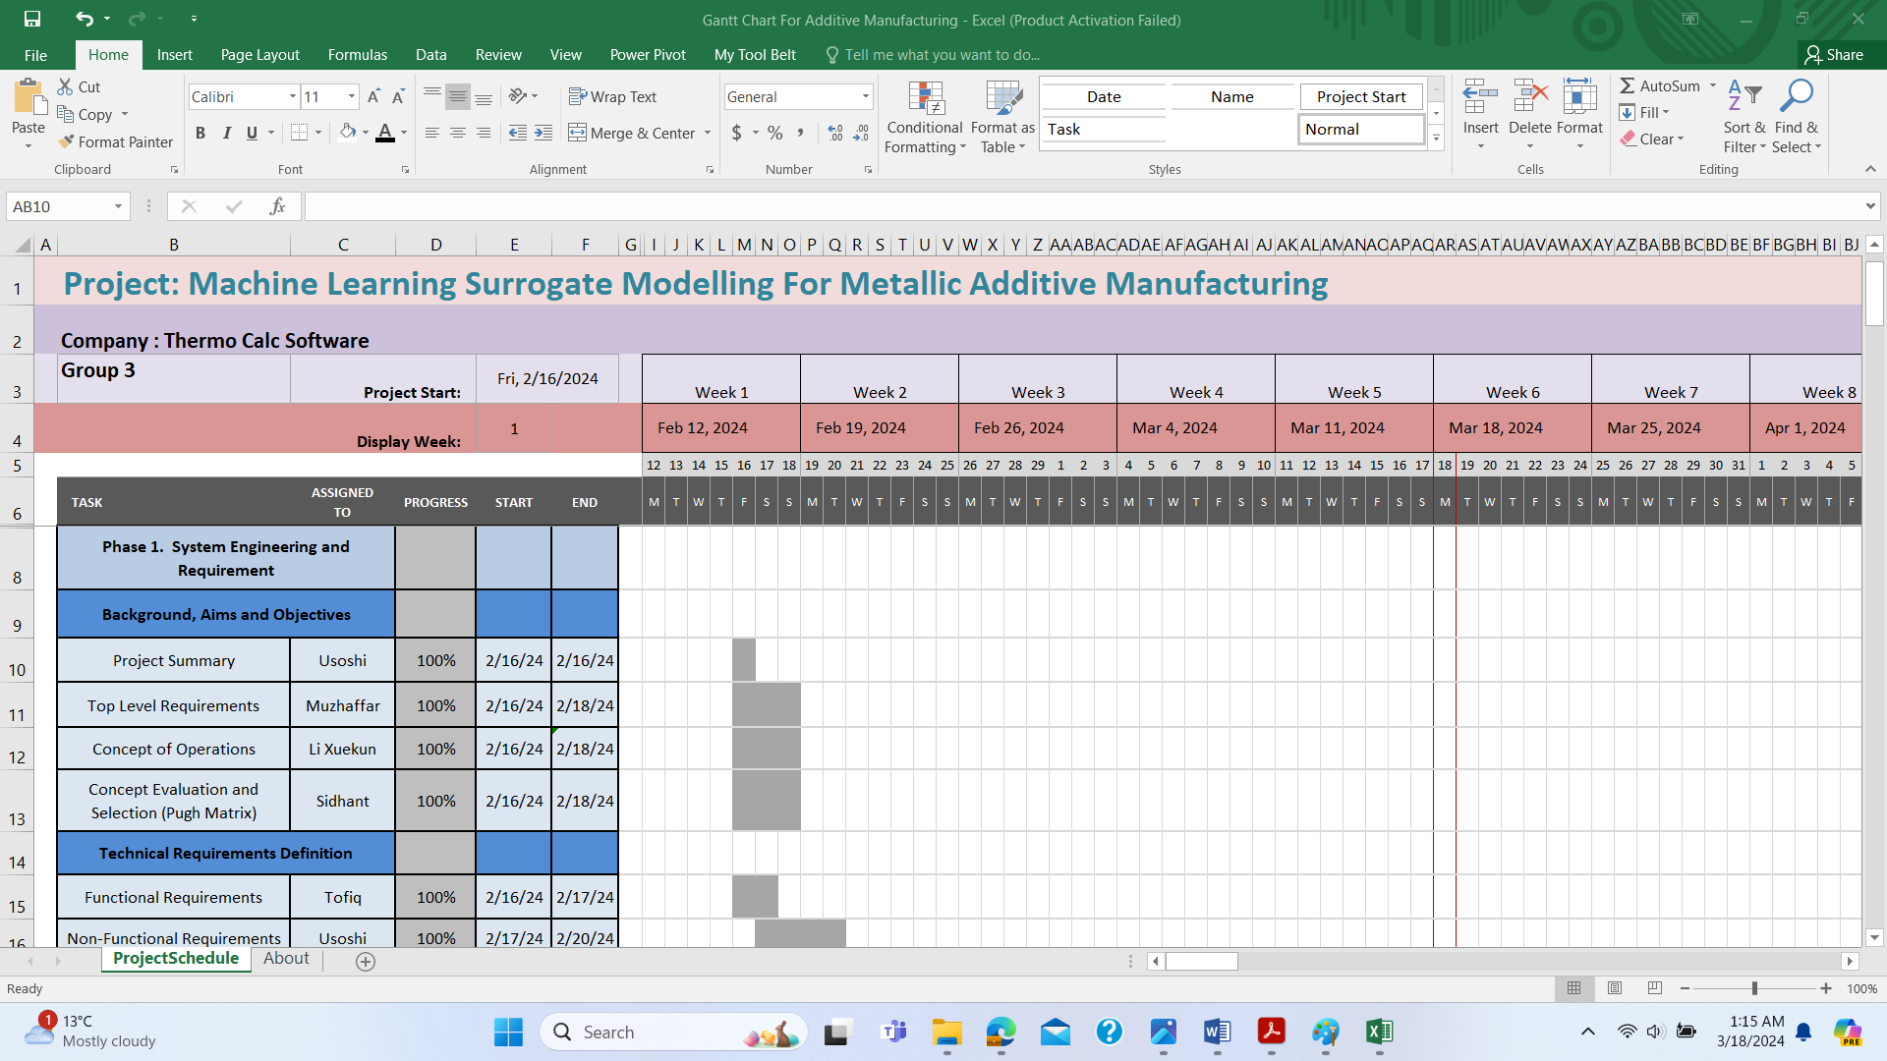

Figure 3: Gantt chart to show the background, aims and objectives section

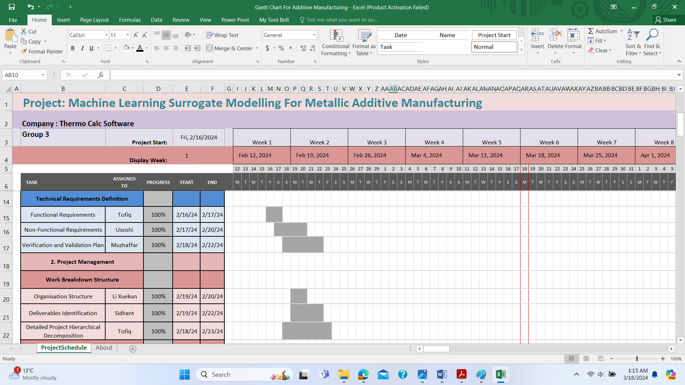

Figure 4: Gantt chart to show the Technical requirements definition and WBS section

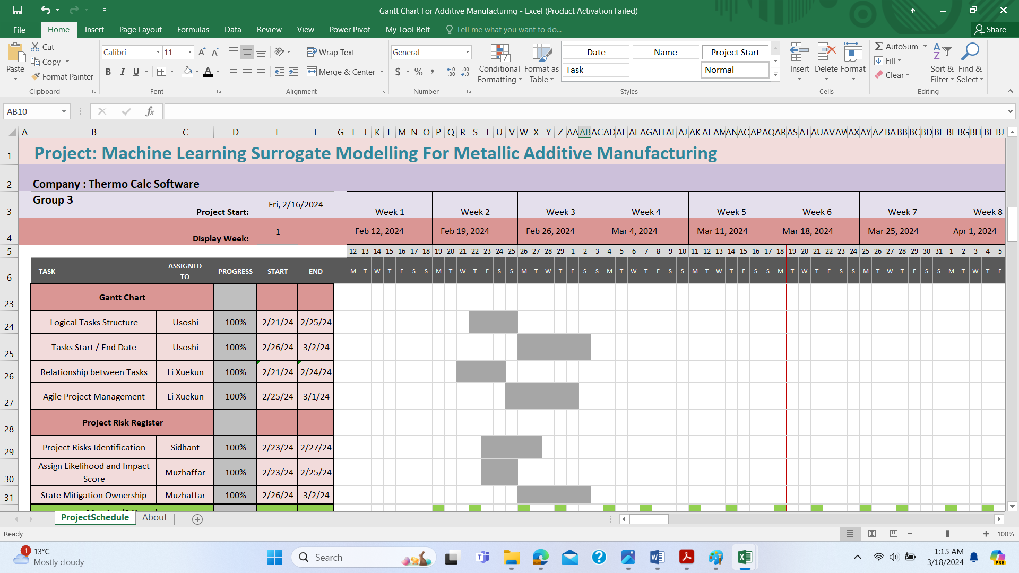

Figure 5: Gantt chart to show the Gantt chart and the risk register section

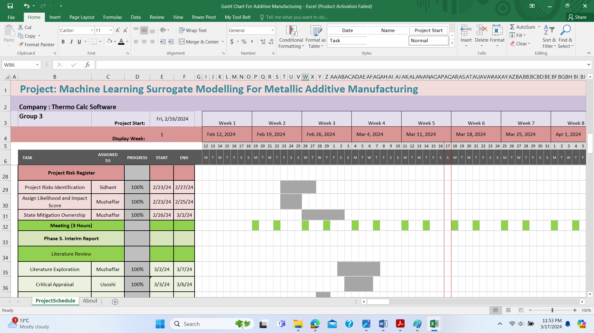

Figure 6: Gantt chart to show the Meetings and Interim Report section

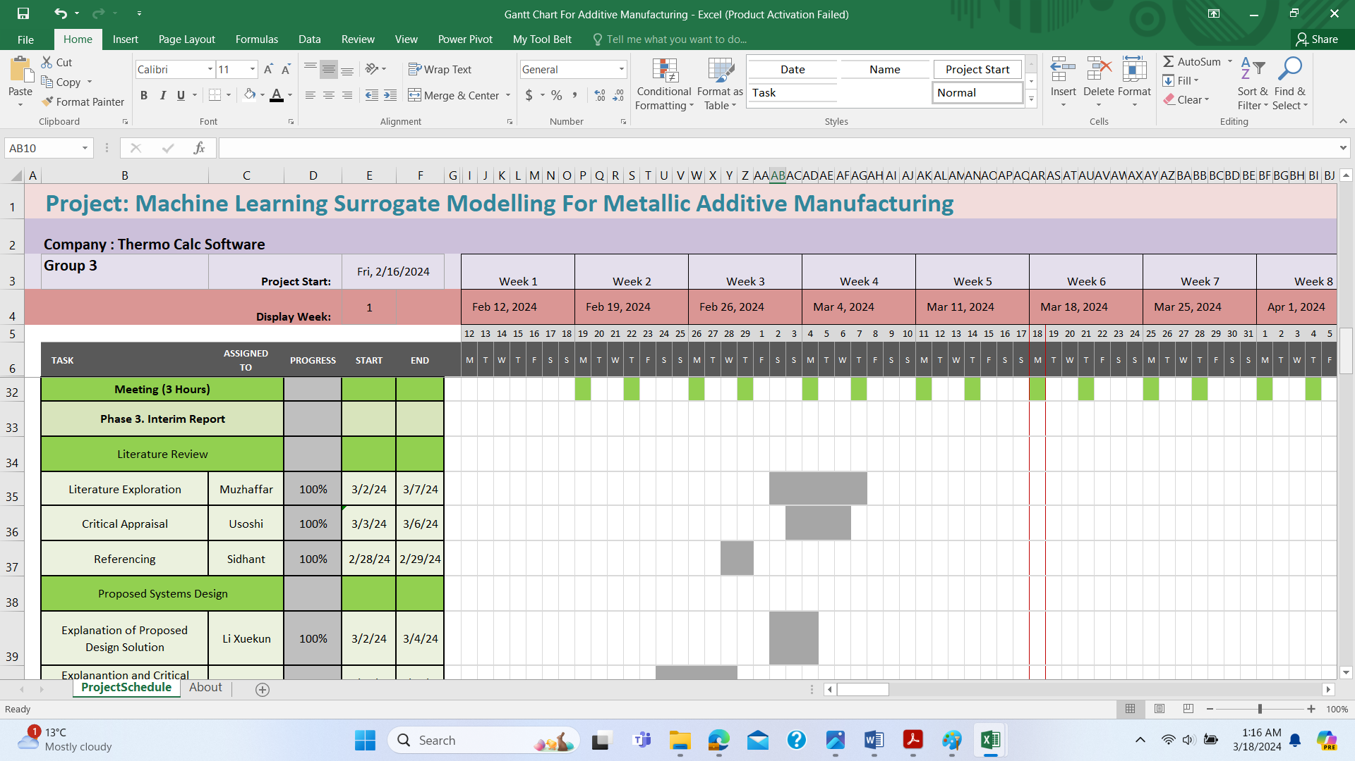

Figure 7: Gantt chart to show the Literature Review and Proposed Systems Design section

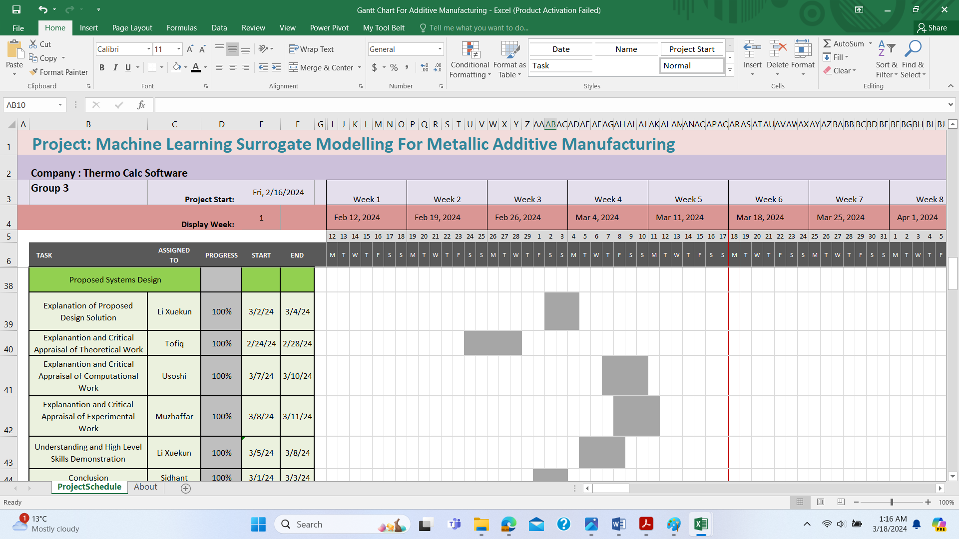

Figure 8: Gantt chart to show the Proposed Systems Design section

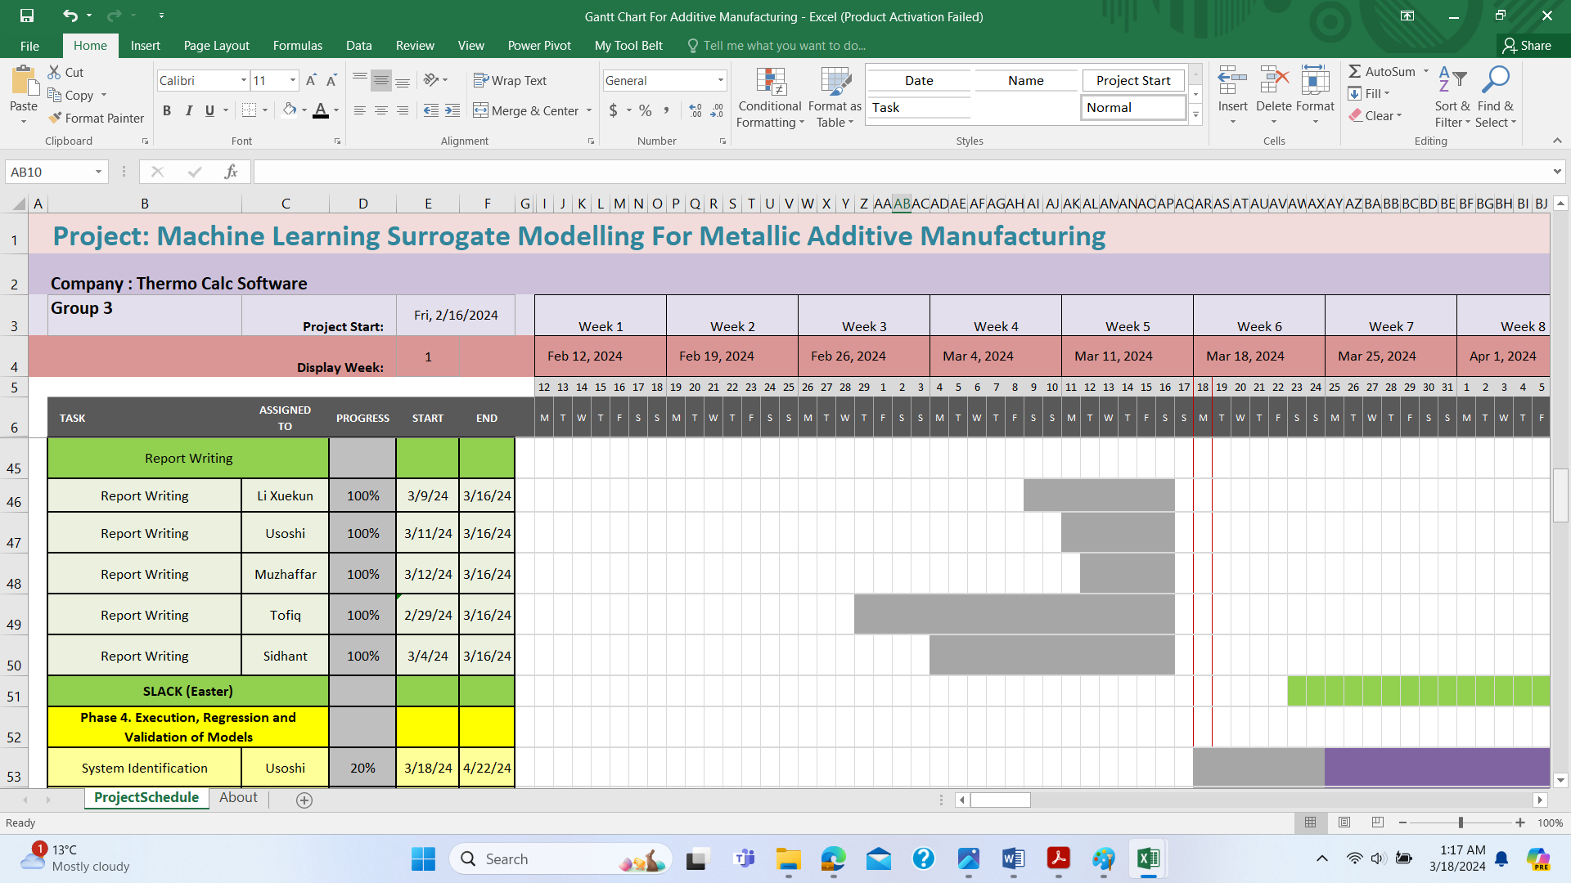

Figure 9: Gantt chart to show Interim Report Writing and slack due to Easter break section



Figure 10:Gantt chart to show the Project execution, regression and validation section

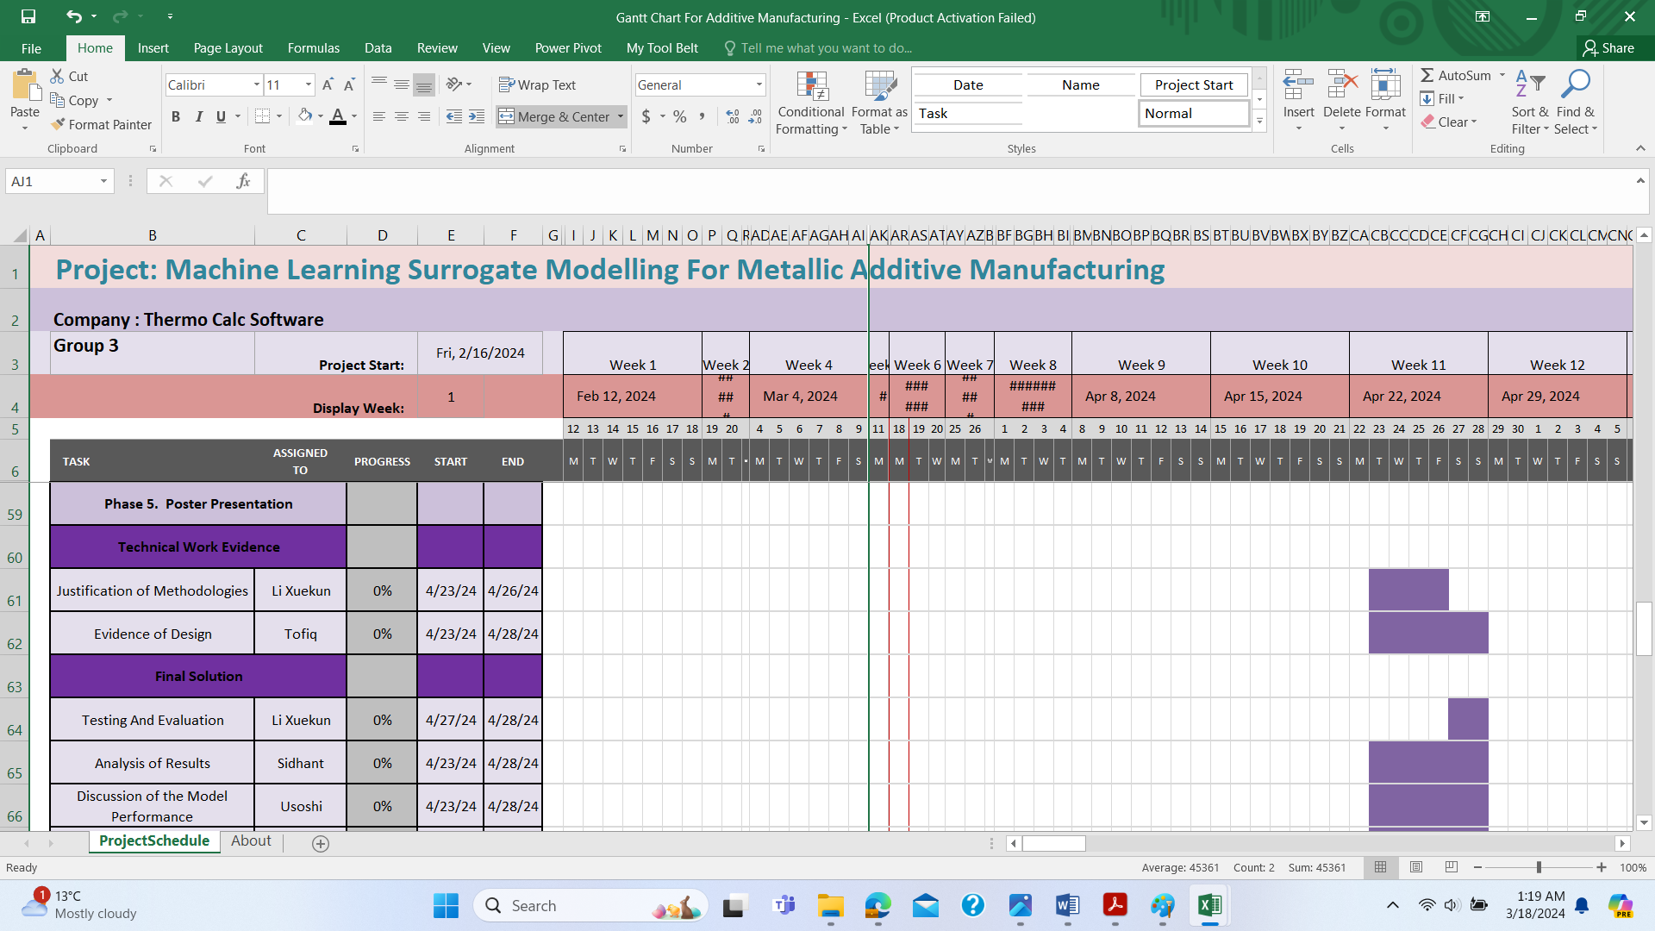

Figure 11:Gantt chart to show the Technical Work Evidence and Final Solution section



Figure 12:Gantt chart to show the Final Solution section



Figure 13: Gantt chart to show the Introduction and Background section



Figure 14:Gantt chart to show the Technical Approach and Results Analysis and Conclusions section



Figure 15: Gantt chart to show the Final Report Writing section

## **4.4** **RISK REGISTER**

Risk register is an important part of the project which lists all possible risks associated with the project and their impact ratios and possible mitigation strategies.

Table 3: Risk register to show the possible risks associated with this project and their mitigation plans



Table 4: Risk Matrix to show the severity and the likelihood associated with the risks

|  |  |  |  |  |
| --- | --- | --- | --- | --- |
| **Severity** | | | | |
| **Likelihood** |  | **High (3)** | **Medium (2)** | **Low (1)** |
| **High (3)** | **9** | **6** | **3** |
| **Medium (2)** | **6** | **4** | **2** |
| **Low (1)** | **3** | **2** | **1** |

# **PROPOSED SYSTEM DESIGN**

## **5.1 SYSTEM IDENTIFICATION**

**Model Selection:**

The data is given in text format. Total 3 input data sets comprising Temperature, MoleFraction_Ca and MoleFraction_Zn and 7 output data sets comprising the Energy_Ca, Energy_Mg, Energy_Zn, DynamicViscosity_Ca, DynamicViscosity_Mg, DynamicViscosity_Zn and MolarVolume are given for analysis. There are total 75000 rows of records in both input and the output data files. The data type is nonlinear in nature as the input data does not always correspond to the output data. Nonlinear ARX model could have been used to estimate the model of the system. But, since, the ARX model involves regressors and the company is not using any closed loop feedback control system in their plant, so linear system identification model is being used to estimate the model. System identification toolbox is being used to estimate the model.

**Data Preprocessing:**

Data needs to be preprocessed first, means removing the redundant data or omitting any data inconsistency is required to achieve the desired results. Then it needs to be sampled and the sampled data needs to be uploaded into Matlab workspace in a matrix format for processing.

**Model Estimation and Validation:**

The model is generated using the system identification toolbox. First the training dataset is uploaded and the model is generated selecting the correct numbers of poles and zeros. Next the model is validated against the validation data set. The model with more than 95% of best fits is selected as the desired model of the system.

**Advantages:**

**Model Understanding:** System identification allows engineers to develop mathematical models that describe the behavior of a system based on observed input-output data. These models provide insights into the underlying dynamics and relationships within the system.

**Model Prediction:** Once identified, models can be used to predict the future behavior of the system under various conditions. This predictive capability is valuable for planning, optimization, and decision-making processes.

**Control System Design**: Identified models serve as the foundation for designing control systems. Engineers can analyze the system's behavior, design controllers, and simulate control strategies using the identified model before implementing them in the real system.

**System Optimization:** Models derived from system identification can be used for optimization purposes, such as improving system performance, minimizing energy consumption, or optimizing resource allocation.

**Reduced Testing Costs:** Instead of conducting extensive experimental testing or relying solely on theoretical models, system identification allows engineers to leverage measured data from real systems. This can significantly reduce testing costs and time.

**Performance Evaluation:** Identified models enable engineers to evaluate the performance of the system under different operating conditions or in response to external disturbances. This helps in assessing system robustness and identifying areas for improvement.

**Disadvantages:**

**Data Requirement:** System identification relies heavily on high-quality input-output data. Obtaining sufficient and representative data can be challenging, especially for complex systems or systems operating in dynamic environments.

**Model Complexity:** Estimating accurate models for complex systems often requires complex model structures, which can be difficult to interpret and implement in practice. Overly complex models may also suffer from overfitting and poor generalization to unseen data.

**Model Uncertainty:** Estimated models are subject to uncertainty due to noise in the data, modeling errors, and parameter estimation inaccuracies. Uncertainty quantification and model validation are essential but can be challenging tasks.

**Computational Complexity:** Estimating models using advanced techniques or dealing with large datasets can be computationally intensive and time-consuming. This can be a limitation, especially for real-time applications or systems with strict computational constraints.

**Assumption Violation:** Many system identification techniques rely on assumptions such as linearity, stationarity, and known input signals. Violating these assumptions can lead to inaccurate model estimates and unreliable predictions.

**Limited Interpretability:** Complex models derived from system identification may lack interpretability, making it challenging to gain insights into the underlying system dynamics. Simplifying models without compromising accuracy can be a non-trivial task.

## **5.2 LINEAR REGRESSION**

Linear regression predicts the relationship between two variables by assuming a linear connection between the independent and dependent variables**[10]**. It seeks the optimal line that minimizes the sum of squared differences between predicted and actual values.

In our additive manufacturing project, we've devised a meticulous process to harness the power of linear regression for optimizing our manufacturing processes. It all begins with the collection of a comprehensive dataset, meticulously structured to include crucial variables such as build temperature, layer thickness, printing speed, and more, ensuring that we cover all facets of the manufacturing process. Once our data is in hand, we embark on a journey of data preprocessing, meticulously handling missing values, outliers, and categorical variables to ensure the pristine quality of our dataset.

With our dataset primed and ready, we move on to the critical step of data splitting, where we divide our dataset into training and testing sets. This segmentation allows us to train our linear regression model on a subset of data while reserving another portion for independent evaluation, ensuring the robustness and generalizability of our model.

As we delve deeper into model training, we rely on cutting-edge machine learning libraries like scikit-learn to instantiate and fit our linear regression model to the training data. This phase marks a pivotal moment as we equip our model with the predictive capabilities to discern the intricate relationships between process parameters and part characteristics.

Once our model is trained, it's time for rigorous evaluation. We meticulously assess its performance on the testing set, employing key metrics such as mean squared error and R-squared to gauge its efficacy in accurately predicting part quality and performance.

And finally, as we interpret the coefficients of our linear regression model, we uncover invaluable insights into the nuanced interplay between process parameters and part characteristics. These insights not only inform our current manufacturing processes but also pave the way for future optimizations and innovations in additive manufacturing.

**Advantages and Disadvantages of Using Linear Regression in Machine Learning**

*Advantages:*

Interpretability: Linear regression provides straightforward interpretation of results. The coefficients associated with each independent variable indicate the strength and direction of its relationship with the dependent variable **[12]**.

Simplicity: Linear regression is easy to understand and implement, making it suitable for beginners in machine learning. Its simplicity also allows for faster computation and model training.

Efficiency with Linear Relationships: When the relationship between the dependent and independent variables is approximately linear, linear regression tends to perform well and provide accurate predictions **[11]**.

Feature Importance: Linear regression can be used to identify the most influential features by examining the magnitude and significance of their coefficients. This feature selection capability is beneficial for data exploration and model simplification.

Baseline Model: Linear regression serves as a baseline model for comparison with more complex machine learning algorithms. It provides a simple benchmark to assess the performance of advanced models **[13]**.

*Disadvantages:*

Limited Complexity: Linear regression assumes a linear relationship between variables, which may not accurately capture the underlying patterns in complex datasets. It fails to model non-linear relationships effectively.

Sensitivity to Outliers: Linear regression is sensitive to outliers, as they can disproportionately influence the estimation of coefficients and degrade model performance **[14]**. Preprocessing techniques such as outlier removal or transformation may be necessary to mitigate this issue.

Assumption Violations: Linear regression relies on several assumptions, including linearity, independence, homoscedasticity, and normality of residuals **[17]**. Violations of these assumptions can lead to biased estimates and unreliable predictions.

Overfitting and Underfitting: Linear regression is prone to both overfitting and underfitting. Overfitting occurs when the model captures noise in the data, while underfitting arises when the model is too simplistic to capture the underlying patterns. Regularization techniques such as Ridge or Lasso regression can help mitigate overfitting **[16]**.

Limited Expressiveness: Linear regression may not capture complex interactions or higher-order relationships between variables **[15]**. For datasets with intricate structures or nonlinear dependencies, more sophisticated machine learning models such as decision trees, random forests, or neural networks may be more appropriate **[18]**.

In summary, while linear regression offers simplicity, interpretability, and efficiency in modeling linear relationships, it also has limitations concerning its ability to handle non-linearity, outliers, and violation of assumptions. Understanding these advantages and disadvantages is crucial for selecting the appropriate modeling technique based on the characteristics of the data and the objectives of the machine learning task.

## **5.3 POLYNOMIAL REGRESSION**

**Comparison of linear and polynomial regression.**

**Introduction**

Additive Manufacturing (AM), also known as 3D printing, has gained prominence in various industries due to its ability to produce complex geometries with high precision . Optimizing AM processes is crucial for achieving desired part quality, reducing production time, and minimizing material waste **[19]**. In this report, we explore the application of polynomial regression in optimizing additive manufacturing parameters and discuss its advantages over linear regression specifically in the context of additive manufacturing.

**Linear Regression Overview in Additive Manufacturing**   
In additive manufacturing, linear regression is frequently used to describe the connection between process parameters and output variables**[20]**. It does, however, make the assumption that variables have a linear connection, which could not accurately represent the intricate interactions present in AM systems.

**Advantages of Polynomial Regression in Additive Manufacturing**

 Flexibility to Capture Non-linear Relationships:

Additive manufacturing processes often exhibit non-linear behaviors due to complex interactions between parameters such as build temperature, layer thickness, and print speed. Polynomial regression offers greater flexibility by allowing for higher-order terms, enabling the model to capture non-linear relationships more accurately.

Improved Model Fit for Complex Processes:

By incorporating polynomial terms, the regression model can better fit the data, reducing bias and variance. This improved model fit is especially beneficial in additive manufacturing, where the relationship between process parameters and part characteristics can be highly intricate and non-linear.

Multi-dimensional Analysis of Process Parameters:

Additive manufacturing processes involve multiple parameters that interact in non-linear ways. Polynomial regression can analyze these multi-dimensional relationships, providing insights into how different parameters affect part characteristics such as strength, surface finish, and dimensional accuracy.

Enhanced Process Optimization:

Polynomial regression facilitates the optimization of additive manufacturing processes by identifying the optimal combination of parameters to achieve desired outcomes**[21]**. By accurately modeling the process-response surface, polynomial regression guides process engineers in making informed decisions to improve part quality and productivity.

**Disadvantages of Polynomial Regression in Additive Manufacturing**

Enhanced Intricacy:   
Adding higher-order terms to polynomial regression models might make them more complicated and difficult to grasp. But in additive manufacturing, where it's common for process optimization to take into account a variety of variables and interactions, the extra complexity might not be that big of a disadvantage.

Increased Awareness of Outliers:  
Compared to linear regression, polynomial regression could be more susceptible to outliers, which could cause distortions in the model's predictions**[22]**. However, modest sensitivity to outliers may not have a significant negative influence on model performance in additive manufacturing, because data may display intrinsic variability owing to process noise or material discrepancies.

Risk of Overfitting:  
Higher-order terms in polynomial regression models increase the likelihood of overfitting the training set and capturing noise instead of real underlying patterns. Although overfitting can result in subpar generalization performance, cross-validation and careful model selection can frequently reduce overfitting in additive manufacturing projects where empirical testing and validation are standard procedures.

Increasing Requirements for Computation:  
  
In comparison to linear regression, polynomial regression models including higher-order components demand greater processing power for model estimation and prediction**[23]**. Nevertheless, the higher computing demands might not be a major obstacle in additive manufacturing projects because optimization processes are usually carried out offline and computational resources are more easily accessible.

Possibility of Extrapolation Errors:

When extending outside the range of observed data, polynomial regression models may show increased uncertainty, particularly when dealing with higher-order factors. Extrapolation errors, however, might not be a major worry in additive manufacturing initiatives that concentrate on process optimization within defined operating ranges because the focus is frequently on improving current processes rather than forecasting behavior outside of set parameters.

Although there may be some drawbacks using polynomial regression over linear regression, these issues are probably not going to be major issues for your additive manufacturing project **[24]**. Through careful consideration of your project's unique requirements and features, you may take advantage of polynomial regression's benefits while minimizing any potential negative effects to accomplish desired results.

**Application in Additive Manufacturing Project:**

In our additive manufacturing project, polynomial regression can be applied to various optimization tasks, including:

Parameter Optimization: Identifying the optimal values for process parameters such as build temperature, layer thickness, and print speed to maximize part quality and mechanical properties.

Material Selection: Analyzing the effect of material properties on print quality and performance, aiding in material selection and formulation.

Geometry Optimization: Optimizing part design and orientation to minimize support structures, reduce printing time, and enhance surface finish using polynomial regression-based simulations.

**Conclusion:**

Polynomial regression offers significant advantages over linear regression in optimizing additive manufacturing processes. Its flexibility to capture non-linear relationships, improved model fit for complex processes, multi-dimensional analysis capabilities, and enhanced process optimization potential make it a valuable tool for achieving high-quality AM parts efficiently and reliably.

## **5.4 SUPPORT-VECTOR REGRESSION**

The goal of the support vector machine algorithm is to identify a hyperplane within an N-dimensional space (where N represents the number of features) that clearly differentiates the data points. Among the numerous potential hyperplanes available for dividing the two classes of data points, the aim is to select the one with the widest margin, meaning the greatest separation between the data points from each class. By maximizing this margin, the algorithm strengthens its ability to classify future data points more accurately and with greater assurance.

**Step-by-step of Support Vector Regression Process**

**Data Preparation:** As with any machine learning task, data preparation is key. This includes dealing with missing values, encoding categorical variables, feature scaling, etc.

**Choosing a Kernel:** SVM can use a technique called the "kernel trick" to transform data and then find an optimal boundary between the possible outputs. Common kernels include linear, polynomial, radial basis function (RBF), and sigmoid.

**Model Training:** SVM finds the hyperplane that maximizes the margin between two classes. The data points that are closest to the hyperplane are called support vectors, as they are key to defining the hyperplane.

**Maximizing the Margin:** The algorithm tries to maximize the distance (margin) between the data points of separate classes. The best hyperplane is the one with the largest margin.

**Handling Non-Linear Data:** For non-linearly separable data, SVM uses a kernel to map data to a higher-dimensional space where a hyperplane can be used to separate the classes.

**Regularization Parameter (C):** SVM has a regularization parameter, C, which controls the trade-off between achieving a low training error and a low testing error that is, a balance between under fitting and overfitting.

**Prediction:** After the model is trained, it can be used to predict the class of new data points. The decision function depends on the type of kernel used.

**Model Evaluation:** Finally, the model is evaluated using metrics like accuracy, precision, recall, F1 score, etc., depending on the specific task.

Advantages:

**Robustness:** Particularly effective in high-dimensional spaces.

**Flexibility:** Capable of defining complex higher-order relationships with the help of kernels.

**Generalization Ability:** Often results in better generalization, reducing the risk of overfitting.

Disadvantages and Challenges:

**Parameter Selection:** The performance of SVM is heavily dependent on the correct setting of parameters such as the kernel type, kernel parameters, and margin parameter C.

**Scalability and Efficiency:** SVMs can be computationally intensive, making them less viable for large datasets.

**Interpretability:** SVM models, especially with non-linear kernels, can be difficult to interpret compared to simpler models.

The Support Vector Machine (SVM) algorithm functions by creating a hyperplane capable of segregating data into two or more categories. To achieve accurate data classification, this hyperplane must be precisely adjusted. SVM is effectively employed in identifying defects in parts, fault diagnosis in 3D printers, and in the creation of process maps. Enhancing the accuracy of this algorithm is possible through various techniques that transform input data into feature space. These methods include transfer component analysis and sensor modalities **[24]**.

## **5.5 RANDOM FOREST**

This process is used to predict continuous values. It is an ensemble learning method that includes creation of multiple decision trees during training and outputting the mean prediction of each individual tree.

The main steps before the actual modelling includes:

**Data Collection:** Gathering data which includes the independent and dependent variables

**Data Preprocessing:** This step involves cleaning data, handling missing values and scaling if necessary

**Data Splitting:** Data needs to be divided into training and testing data.

**Random Forest Training:**

**Tree Construction:** creation of multiple trees. A random subset of training data (using concept of bootstrap sample) and a random subset of the features is used for training each tree.

**Splitting Nodes:** At each node of the tree, a subset of features is considered, and the selection is done based on the feature that provides the best split according to certain criterion like Gini impurity or entropy.

**Tree Growth:** The tree growth continues until a minimum number of leaf nodes is reached or maximum depth.

Once the forest of trees is made, predictions are made for each tree, out of which the final prediction is where the average of predictions from each individual tree is taken.

To evaluate the performance of the Random Forest Regression methods like Mean Squared Error (MSE) or R-Squared can be used.

Hyper parameters such as number of trees in the forest, the maximum depth of each tree or the number of features considered at each split can be tuned to develop better performance. These tuning can be done by techniques like cross-validation.

Reason for using Random Forest Regression for surrogate modelling:

Provides high accuracy compared to other regression methods

They can be used for modelling complex nonlinear relationships between features and target variables. The data provided has a lot of nonlinear relationships hence the use of Random forest regression helps for the required applications.

Since there is averaging of predictions from multiple trees, it is less prone to overfitting.

Since our datasets have large number of features random forest has the advantage of handling datasets with large features and dimensionality.

The regression model is robust to noise, uncertainties and outliers due to the averaging of multiple trees. This makes it robust to overfitting as well.

Random Forest Regression provides a feature importance score giving an idea of which input has the most influence on the output. This helps in understanding the relation between the input data and the required output data which provides insights into the underlying behavior in the system.

The regression techniques make no assumption about the distribution of the data.

Due to parallelization, the modelling technique takes advantage of distributed computing resources for training the large provided dataset. It becomes helpful for the tasks during surrogate modelling involving computationally expensive simulation or experiments.

Disadvantages of Random Forest regression:

The modelling is computationally expensive especially with large datasets and features as they need large number of trees to be created.

The interpretation of individual trees within the forest can be difficult making the overall decision-making process not be as straightforward as compared to simpler models.

Since the modelling process involves creation of multiple tress, the large dataset provided requires a lot of memory and hence becomes memory-intensive.

Since it is a black-box model, using the model structure to interpret the relationships between features and prediction is pretty difficult.

Random Forest is generally less sensitive to hyper parameters, tuning of the number of trees and maximum depth helps in optimal performance requiring high experimental and computational resources.

The existence of imbalanced data (especially where one class significantly outnumbers the others), Random Forest may not perform well.

Garg et al. provided a compelling example of Random Forest Regression in their work **[27]**. They discuss the application of this modeling method within the framework of the First-Order Shear Deformation Theory (FSDT) and its significance in analyzing laminated composite plates and shells. The authors also delve into the challenges associated with using FSDT to predict the behavior of laminated composite structures compared to elasticity solutions. Moreover, they introduce random forest surrogates and highlight their advantages over previous surrogate models employed for laminated composite structures. Analyzing the available literature **[28]** for about comparison of different performances of ML methods for prediction of delamination in composite beams and usage of Random Forest for fracture behavior of composites presented in **[29]** helped in the selection of random forest as a technique for the application. Zhang et al. **[30]** reporting the superiority of random forest in both training time and accuracy of prediction for laminated composites also helped in the selection of this modeling technique.

The authors propose a method for utilizing Random Forest surrogates to transform FSDT predictions into elasticity solutions. They present a detailed procedure, including preprocessing steps, and discuss the potential benefits, such as improved accuracy and computational efficiency. Additionally, they emphasize the applicability of this method across a wide variety of geometries and loading conditions.

Garg et al.'s research provides valuable insights into the application of Random Forest Regression in the analysis of laminated composite structures, offering a promising approach to address the challenges associated with FSDT predictions and elasticity solutions.

## **5.6 NEURAL NETWORK**

Neural network is a subclass of machine learning algorithms inspired by the functionality of the human brain. The interconnected nodes, or neurons, inside the neural network are organised into layers, with each layer performing specific operations on input data **[31]**. Neural networks have recently gained significant popularity due to the ability of learning complex patterns and making accurate predictions across different domains, including image recognition, natural language processing, and surrogate modelling.

Among the different types of neural networks, the Feedforward Neural Network (FNN) is a basic neural network architecture where information flows one-way only from input to output layer **[32]**. One of the advantages of applying the feedforward neural network is that it is suitable for representing the non-linear relationships in the data, which is appropriate in accelerating the simulation of multi-component diffusion in metal additive manufacturing **[33]**.

**Methodology:**

Collect the dataset of the metal material multi-component diffusion properties.

Preprocess the data (data cleaning, data normalisation, and feature extraction).

Split the dataset into the training data and validation data.

Surrogate modelling the multi-component diffusion through training a feedforward neural network model with the training dataset.

Exploration of the hyperparameter (number of filters and number of layers) inside the designed parameter space.

Validate the trained model against the validation dataset using k-fold cross-validation approach.

Assess the accuracy and computational efficiency of the surrogate model.

Deploy the validated surrogate model in the experimental environment. Enabling the real-time multi-component diffusion prediction of metal additive manufacturing process.

**Expected Outcomes:**

A feedforward neural network surrogate model is successfully trained and being able to predict real-time multi-component diffusion features of the Mg-Zn-Ca alloys in the metal additive manufacturing process. Moreover, other alloy materials are to be tested using the same surrogate model.

In conclusion, using the feedforward neural network approach to build the surrogate model holds immense potential for improving the efficiency and effectiveness of metal additive manufacturing processes. By accurately predicting material diffusion behaviours, the surrogate model developed in this project will enable optimization and decision-making, ultimately leading to improved safety, productivity, quality, and innovation in metal additive manufacturing.

# **PRILIMINARY TECHNICAL PLAN**

**Data Collection:** Gathering of both inputs and outputs from the client or other such relevant sources.

**Data Analysis:** Using visualization techniques like box-plots, creation of heat map and correlation matrix to understand the relationships between the input data and output data.

**Data Preprocessing:** After analyzing data, applying techniques like normalization and selection of most relevant features along with removal of noise and handling missing values to get clean and consistent set of data. These steps are taken to improve the model performance.

**Model Training:** Selection of right machine learning algorithm based on the dimensionality of the dataset acquired from preprocessing. Dividing the input dataset into training and testing data and using the training dataset for model training.

**Sensitivity Analysis:** Using the testing data to determine the certain factors like Mean Square Error (MSE), R-Squared and Mean Absolute Error (MAE). Based on the result given, there is an attempt to get minimum usage of data by using validation processes like k-fold cross validation for better assessment of the model training on the data, hyper parameter tuning and also helps in optimization of data preprocessing.

# **CONCLUSION**

The integration of machine learning (ML) techniques in metal additive manufacturing (AM) has emerged as a transformative approach to address computational variability and complexity in the AM process which enhance the significance of ML in advancing materials development, optimizing process parameters, and predicting material properties. By leveraging ML methodologies, companies can unlock new opportunities for enhancing product quality, reducing production costs, and advancing the adoption of metal AM in various industries. Additionally, the integration of surrogate models (SMs) with computational efficiency is pivotal for advancing engineering design methodologies, particularly in addressing black-box problems and achieving significant savings in computational resources and time. Various surrogate modeling methods, their validation procedures, sensitivity analysis, and practical implementations, guiding the selection of appropriate surrogate models and procedures throughout the modeling process. Moreover, demonstrate the importance of prior-knowledge in improving the predictive performance of trained neural networks, offering a more guided and efficient modeling process of theory-informed data-driven models aligned with physics-based simulations, which would become the baseline of this study case compared with Support Vector Regression, Random Forest Regression, Polynomial Regression, and System Identification by examining its accuracy and computational efficiency. In the context of the assignment's investigation into the role of rapid diffusion in mitigating brittleness in 3D-printed metal parts, insights from ML techniques and surrogate modeling methods, informed by comprehensive thermodynamic and mobility databases, can be utilized to analyze the multicomponent diffusion process. By integrating data related to diffusion kinetics, microstructural evolution, and mechanical properties, ML models can elucidate the relationship between diffusion rate and brittleness reduction, facilitating the optimization of AM processes for desired material properties.

# **REFERENCES**

[1] Kudela, J., Matousek, R. Recent advances and applications of surrogate models for finite element method computations: a review. Soft Comput 26, 13709–13733 (2022). <https://doi.org/10.1007/s00500-022-07362-8>

[2] W. E. Frazier, Metal additive manufacturing: A review, Materials Engineering and Performance, Volume 23, 2014; <https://doi.org/10.1007/s11665-014-0958-z>

[3] Alizadeh, R., Allen, J.K. and Mistree, F. Managing computational complexity using surrogate models: a critical review. Res Eng Design 31, 275–298 (2020). <https://doi.org/10.1007/s00163-020-00336-7>.

[4] N.S. Johnson, P.S. Vulimiri, A.C. To, X. Zhang, C.A. Brice, B.B. Kappes, A.P. Stebner, Invited review: Machine learning for materials developments in metals additive manufacturing, Additive Manufacturing, Volume 36, 2020. <https://doi.org/10.1016/j.addma.2020.101641>.

[5] Mohamed Atwya, George Panoutsos, Structure optimization of prior-knowledge-guided neural networks, Neurocomputing, Volume 491, 2022, pp. 464-488. <https://doi.org/10.1016/j.neucom.2022.03.008>

[6] Introduction to Linear Regression Analysis" by Douglas C. Montgomery, Elizabeth A. Peck, and G. Geoffrey Vining.

[7] Regression Modeling Strategies: With Applications to Linear Models, Logistic and Ordinal Regression, and Survival Analysis" by Frank E. Harrell Jr.

[8] Applied Linear Statistical Models" by Michael H. Kutner, Christopher J. Nachtsheim, John Neter, and William Li.

[9] Regression Analysis by Example" by Samprit Chatterjee and Ali S. Hadi.

[10] Introduction to the Theory of Linear Nonselfadjoint Operators" by V. A. Marchenko and A. Boutet de Monvel.

[11] Analysis of Variance, Design, and Regression: Linear Modeling for Unbalanced Data" by Ronald Christensen.

[12] Regression Analysis: Concepts and Applications" by Saroj Koul.

[13] Applied Regression Analysis and Other Multivariable Methods" by David G. Kleinbaum, Lawrence L. Kupper, and Azhar Nizam.

[14] Nonlinear Regression Analysis and Its Applications" by Douglas M. Bates and Donald G. Watts.

[15] <https://www.analyticsvidhya.com/blog/2021/06/linear-regression-in-machine-learning/>

[16] [https://www.analyticsvidhya.com/blog/2021/10/everything-you-need-to-know-about-linear-regression](https://www.analyticsvidhya.com/blog/2021/10/everything-you-need-to-know-about-linear-regression/)

[17] <https://datatab.net/tutorial/linear-regression>

[18] <https://www.ibm.com/topics/linear-regression#:~:text=the%20next%20step-,What%20is%20linear%20regression%3F,is%20called%20the%20independent%20variable>.

[19] Linear Regression Analysis" by George A. F. Seber and Alan J. Lee.

[20] Applied Linear Regression Models" by John Neter, Michael H. Kutner, Christopher J. Nachtsheim, and William Li.

[21] Regression Modeling Strategies: With Applications to Linear Models, Logistic and Ordinal Regression, and Survival Analysis" by Frank E. Harrell Jr.

[22] Regression Analysis by Example" by Samprit Chatterjee and Ali S. Hadi.

[23] Introduction to Regression Modeling" by Bovas Abraham and Johannes Ledolter.

[24] Joshi, M. S., Flood, A., Sparks, T., & Liou, F. W. (n.d.). *APPLICATIONS OF SUPERVISED MACHINE LEARNING ALGORITHMS IN ADDITIVE MANUFACTURING: A REVIEW*.

[25] Liu, Y., Blunt, L., Gao, F., & Jiang, X. (2021). High-dynamic-range 3D measurement for E-beam fusion additive manufacturing based on SVM intelligent fringe projection system. *Surface Topography: Metrology and Properties*, *9*(3). <https://doi.org/10.1088/2051-672X/ac0c62>

[26] https://builtin.com/data-science/random-forest-python

[27] A. Garg, T. Mukhopadhyay, M. Belarbi, L. Li, Random forest-based surrogates for transforming the behavioral predictions of laminated composite plates and shells from FSDT to elasticity solutions, Compos. Struct. 309 (2023) 116756.

[28] M He, Wang Y, Ram Ramakrishnan K, Zhang Z. A comparison of machine learning algorithms for assessment of delamination in fiber-reinforced polymer composite beams. Struct Heal Monit 2021;20:1997–2012. https://doi.org/10.1177/ 1475921720967157.

[29] Balcıoglu ˘ HE, Seçkin AÇ. Comparison of machine learning methods and finite element analysis on the fracture behavior of polymer composites. Arch Appl Mech 2021;91:223–39. https://doi.org/10.1007/s00419-020-01765-5.

[30] Zhang C, Li Y, Jiang B, Wang R, Liu Y, Jia L. Mechanical properties prediction of composite laminate with FEA and machine learning coupled method. Compos Struct 2022;299:116086. https://doi.org/10.1016/j.compstruct.2022.116086.

[31] Abiodun OI, Jantan A, Omolara AE, Dada KV, Mohamed NA, Arshad H. State-of-the-art in artificial neural network applications: A survey. Heliyon. 2018 Nov 1;4(11).

[32] Goodfellow I, Bengio Y, Courville A. Deep learning. MIT press; 2016 Nov 10.

[33] Chowdhury S, Mhapsekar K, Anand S. Part build orientation optimization and neural network-based geometry compensation for additive manufacturing process. Journal of Manufacturing Science and Engineering. 2018 Mar 1;140(3):031009.